

Project title: EE Connection

Year: 2019

Project supervisor: Mohammed Chamseddine

Students: Jounaid Al-Saadi

Bassam Kaddoura

Contents

Use Case Analysis 3

Use case list table 4

Use case model diagram 5

Use case dependency diagram 6

Narratives, Forms, and Sequence diagrams 7

Navigate 7

Registration 9

Upload CV 11

Login 13

View jobs 15

By Categories 17

Job description 18

Apply 19

Feedback 21

Update Profile 22

Contact 25

Add companies 27

Add jobs 29

Remove jobs 31

View members 32

Edit members 33

Reply 35

Data Modeling 36

Context Data Model 37

Conceptual Data Model 38

Physical Data Model 39

# Use Case Analysis

## Use case list table

|  |  |  |  |
| --- | --- | --- | --- |
| Actor | UC Name | UC Description | UC ID |
| Guest | Navigate | This use case allows all the actors to navigate the system, including information about the system, FAQs, and job listings. | UC0110 |
| Registration -Upload CV | This use case allows the actor to register to become a member through supplying his/her demographic information.  -This use case lets the actor upload his CV as part of the registration process. | UC0120 -UC0121 |
| Member | Login | This use case allows logs the actor into the system as an admin/member depending on the input information. | UC0210 |
| View jobs -By categories -Job description | This use case allows the actor to view available job offerings on the system. -This use case is a part of the “View Jobs” use case and it allows the actor to view the listings in categories by filtering out the categories he is not interested in. -This use case provides a description about the job (Work hours, salary, location, etc…). | UC0220 -UC0221 -UC0222 |
| Apply | This use case allows the actor to apply to a job through automatically sending the CV to the employer. | UC0230 |
| Feedback | This use case gives the option for the actor to send feedback and suggestions to the developers of the page for further improvements. | UC0240 |
| Update Profile | This use case keeps the option of changing the updating on the CV available through the member’s profile. | UC0250 |
| Contact | This use case allows the actor to connect with the admins in order to solve an issue or ask a question. | UC0260 |
| Admin | Login | This use case allows logs the actor into the system as an admin/member depending on the email. | UC0310 |
| Add Companies | This use case grants the ability for admins to add new job companies to the system. | UC0320 |
| Add Jobs | This use case grants the admins the ability to add new job offerings that arise. | UC0330 |
| Remove jobs | This use case gives the admins the ability to remove listings when employers inform them that they have been filled. | UC0340 |
| View members -Edit members | This use case gives the admin access to view certain information about all members so that he/she can properly moderate the system. -This use case gives the admin permission to act on members’ accounts ( delete, ban, warn, edit), in order to keep the system under control. | UC0350 -UC0351 |
| Reply | This use case allows for admins to message the members back regarding issues they are facing or questions they are having about the system. | UC0360 |

Made with Microsoft Excel

## Use case model diagram

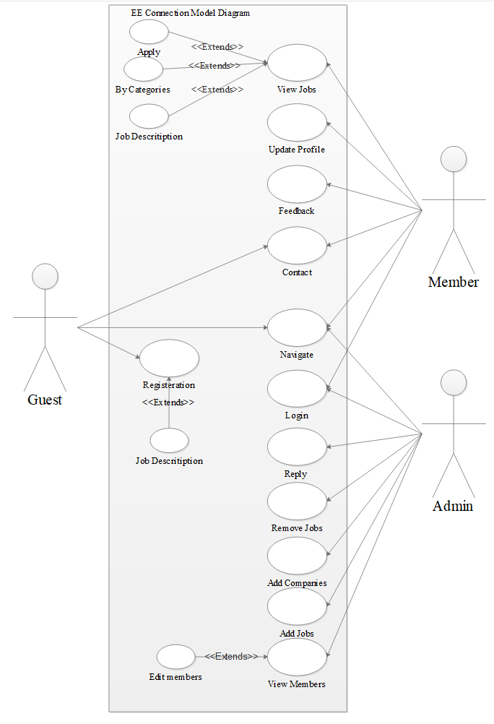

Made with Edraw Max

## Use case dependency diagram

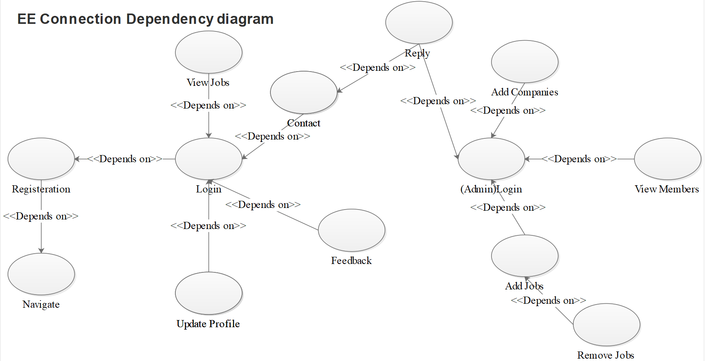

Made with Edraw Max

## Narratives, Forms, and Sequence diagrams

**Sequence diagrams were made using Lucidchart**

### Navigate

|  |  |  |
| --- | --- | --- |
| Use-Case Name: | Navigate | |
| Use-Case ID: | UC0110 | |
| Priority: | High | |
| Participating Actors: | * Guest * Member * Admin | |
| Description: | This use case describes the event of a guest/member/admin just viewing the homepage and information of the website without making any changes that communicates with the database, the guest is not given access to the job listings as he/she needs to register before being able to view that section of the system. | |
| Precondition: | There is no precondition for this use case. | |
| Trigger: | This use case is triggered upon visiting the website. | |
| Typical Course Events: | Actor Action | System Response |
| * **Step** 1: The actor enters the website and is now viewing the home page. * **Step** 2: The actor clicks on “Give Us Feedback”/”Find a Job”/”Contact”/ | * **Step** 3: The System directs him/her to the relevant page. |
| Alternate Courses: | * Alt-Step 3: The actor is not logged in and tries to access the job listings’ section, the system instead suggests that he/she should register in order to get access to this section. | |
| Conclusion: | The navigation event is always active and concludes only when the actor leaves the system and his/her session is closed. | |
| Postcondition: | The actor was able to view the homepage and information section of the page, and in case he/she was not a member and trying to access specific sections, he/she was prompted to register before doing so. | |

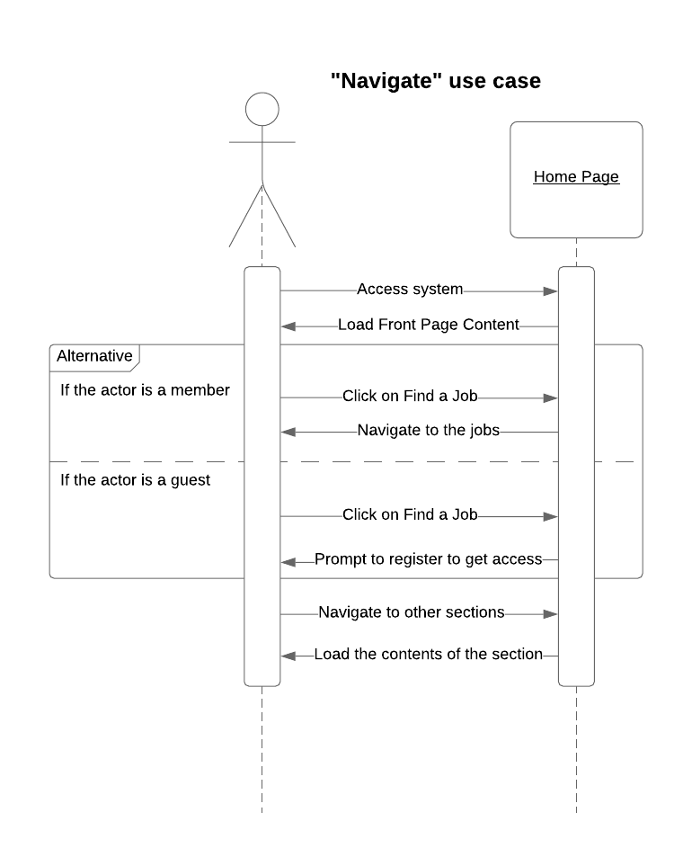





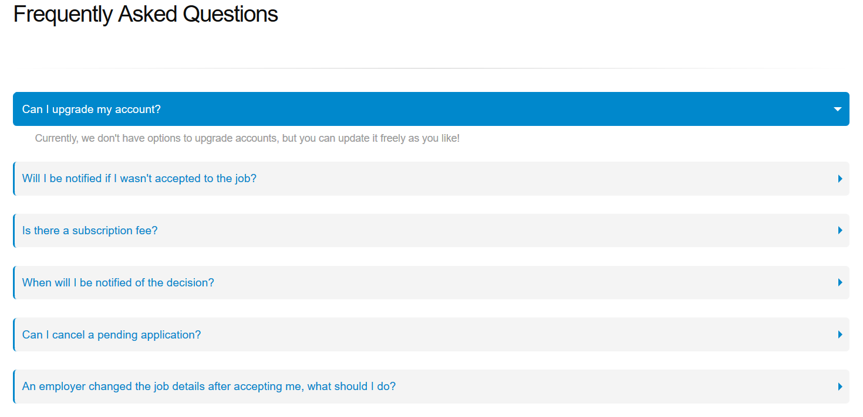

### Registration

|  |  |  |
| --- | --- | --- |
| Use-Case Name: | Registration | |
| Use-Case ID: | UC0120 | |
| Priority: | High | |
| Participating Actors: | Guest | |
| Description: | This use case describes the event of a guest choosing to make an account on the system, this event will prompt the actor to enter his/her information (email, name, phone number, address, CV, etc.…), thus becoming a member. Once it’s verified that his/her email is not already in the system and that the password meets the requirements, the account will be made and stored in the system. | |
| Precondition: | The actor must be navigating the system. | |
| Trigger: | This use case is triggered upon click the “Register” button on the top right of the website. | |
| Typical Course Events: | Actor Action | System Response |
| * **Step** 2: The actor enters account email. * **Step** 4: The actor enters his desired account password. * **Step** 6: The actor chooses whether to enter the rest of the non-required information (Phone number, address, etc...) * **Step** 7: Clicks on the Upload CV button * **Step** 9: Checks the “I agree to terms and conditions” checkbox. * **Step** 10: Clicks on the “Register” button. | * **Step** 1: The system directs the actor to the registration page. * **Step** 3: The system verifies that the email is not already related to an existing account. * **Step** 5: The system verifies that the entered password meets all the required password conditions ( more than 8 characters, at least 1 digit, at least 1 capital letter, etc...) * **Step** 8: System triggers use case UC0121 * **Step** 11: System sends a confirmation email to the actor. * **Step** 12: System creates the account in the Person database. |
| Alternate Courses: | * Alt-Step 4: The email already exists in the database; the system warns the actor and asks him/her to enter a new one. * Alt-Step 6: The password does not match the required conditions; the system warns the actor and asks him/her to change it. * Alt-Step 12: The actor did not check the “I agree to terms and conditions” checkbox; the system informs the actor that he must agree to the terms and conditions. | |
| Conclusion: | This use case concludes when the actor enters all the information properly, and the system successfully creates the account in the Person database. | |
| Postcondition: | The actor is now a member of the system, can login, and has access to all the sections and system functions that are member-exclusive. | |

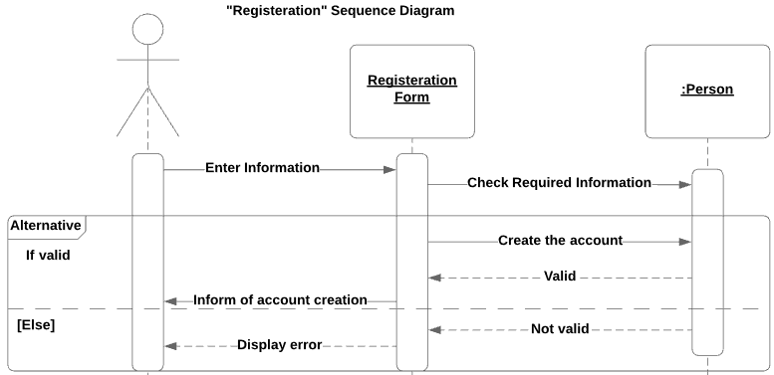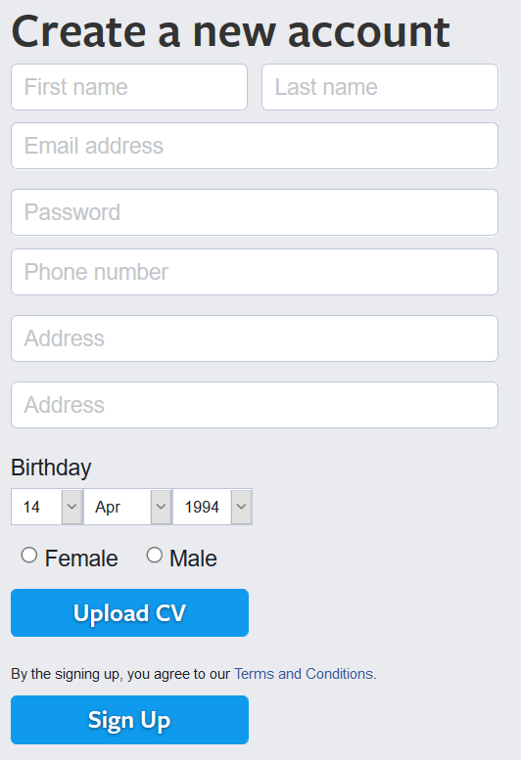

### Upload CV

|  |  |  |
| --- | --- | --- |
| Use-Case Name: | Upload CV | |
| Use-Case ID: | UC0121 | |
| Priority: | High | |
| Participating Actors: | Guest | |
| Description: | This use case is a part of the registration use case; it describes the event of requiring the guest registering to upload his/her CV as part of the information needed to become a member, once the guest uploads his/her CV, it will become a part of the account, the CV can be replaced/edited later. | |
| Precondition: | The actor must be on the registration form. | |
| Trigger: | This use case is triggered upon clicking the “Upload CV” button in the registration form. | |
| Typical Course Events: | Actor Action | System Response |
| * **Step** 2: The actor chooses the document to upload. | * **Step** 1: The system opens a new window to let the actor browse his PC or Cloud for the document. * **Step** 3: The system verifies that the document is of the (.doc/.docx/.HTML/.PDF/.txt) format. * **Step** 4: The system attaches the document to the form. |
| Alternate Courses: | * Alt-Step 4: The document that actor enter is not of a supported format; the system asks the actor to upload a new document while showing what formats are supported. | |
| Conclusion: | This use case concludes when the actor uploads a CV of a supported format and the system attaches it to the form. | |
| Postcondition: | The actor is able to upload the CV of his choice | |

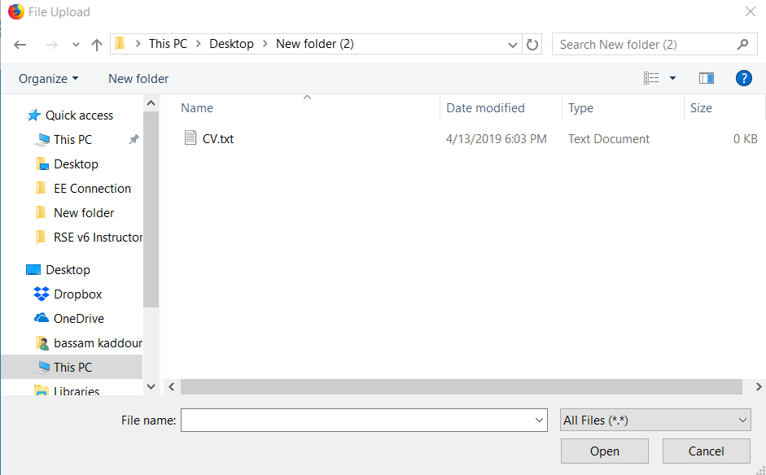

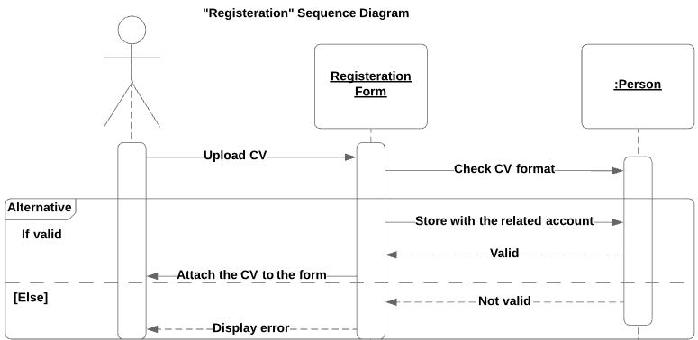

### Login

|  |  |  |
| --- | --- | --- |
| Use-Case Name: | Login | |
| Use-Case ID: | UC0210 | |
| Priority: | High | |
| Participating Actors: | * Member * Admin | |
| Description: | This use case describes the event of a member choosing to sign into the system with his/her account, the member is asked to enter his/her account email and password to log into his/her account. The system will verify the credentials and log the session, it will then check if the account is an administrative or a regular one and grant the actor access accordingly. | |
| Precondition: | The member must be registered beforehand in order to be able to login. | |
| Trigger: | This use case is triggered upon clicking the “Log in” button in the upright corner of the website. | |
| Typical Course Events: | Actor Action | System Response |
| * **Step** 1: The actor enters his account email. * **Step** 2: The actor enters his password. | * **Step** 3: The system verifies that an account with this email exists. * **Step** 4: The system checks whether the email belongs to an admin or a member * **Step** 5: The system verifies that the password matches the account linked to the email. * **Step** 6: The system logs the actor into his account. |
| Alternate Courses: | * Alt-Step 3: The actor entered an email with no account linked to it; the system informs the actor and asks him/her to change the email or to register. * Alt-Step 4: The actor entered the wrong password; the system informs the actor and asks him/her to re-enter the password. | |
| Conclusion: | This use case concludes when the actor enters the correct information of his/her account and is successfully logged into his/her account. | |
| Postcondition: | The actor can access his account in order to use certain member-exclusive functions of the system. | |

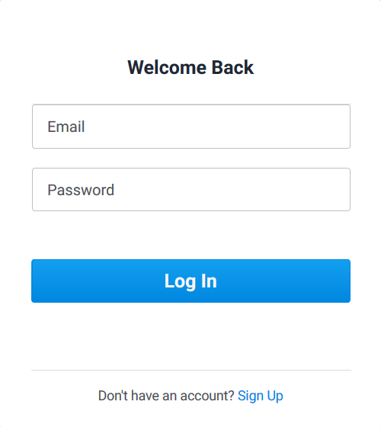

|  |  |  |
| --- | --- | --- |
| Use-Case Name: | View jobs | |
| Use-Case ID: | UC0220 | |
| Priority: | High | |
| Participating Actors: | Member | |
| Description: | This use case describes the event of a member deciding to view the listed available job offerings, there will be options to filter the jobs into categories. The member will also be able to view the job description.  Guests don’t have access to this section to encourage them to sign up and apply through our system, else they could view the job and then proceed to directly contact the employer. | |
| Precondition: | The member must be logged in. | |
| Trigger: | This use case is triggered upon clicking “Find a Job” in the navigation menu, or the “I want to work” button on the front page. | |
| Typical course events: | Actor Action | System Response |
| There is no action beyond the trigger. | * **Step** 1: Direct the actor to the page where jobs are listed |
| Alternate Courses: | There are no alternate courses. | |
| Conclusion: | This use case concludes when the “Find A Job” page fully loads. | |
| Postcondition: | The actor can now scroll through our wide range of different job listings in order to choose the job he/she desires. | |

### View jobs

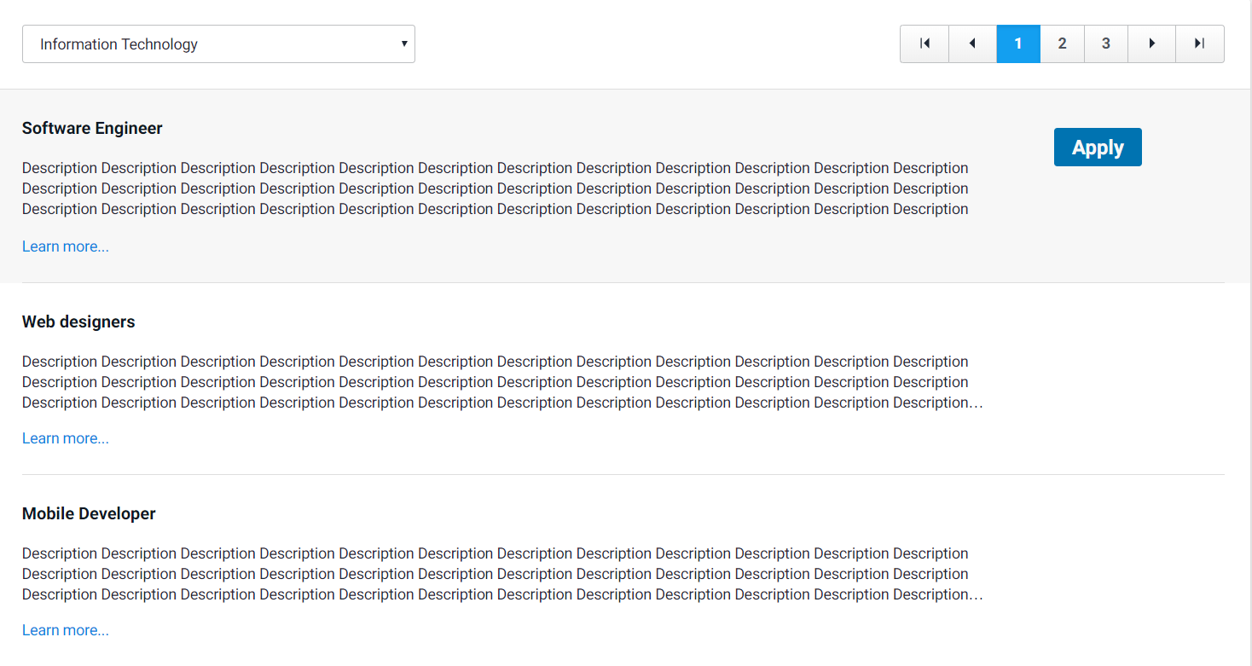

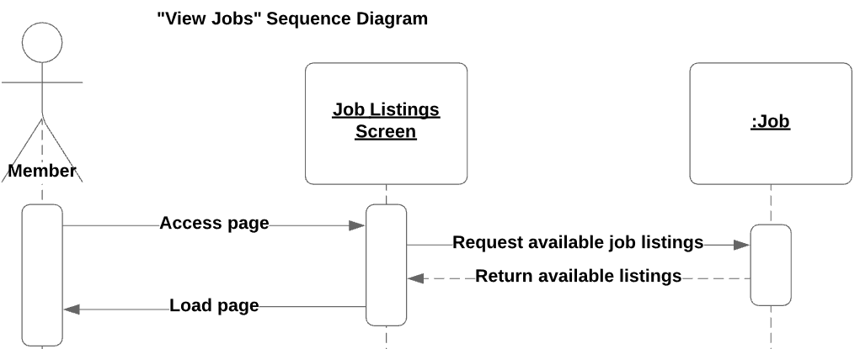

### By Categories

|  |  |  |
| --- | --- | --- |
| Use-Case Name: | By Categories | |
| Use-Case ID: | UC0221 | |
| Priority: | High | |
| Participating Actors: | Member | |
| Description: | This use case is a part of the “View Jobs” case, where the member can view the jobs based on its type, this way, the actor can easily filter out the jobs he/she is specifically seeking without having to go through those which he/she does not care about. | |
| Precondition: | The actor must be logged in and browsing job listings. | |
| Trigger: | Clicking the “Job category” drop down menu and choosing a specific category. | |
| Typical Course Events: | Actor Action | System Response |
| * **Step** 2: The actor chooses one or more categories on the list. | * **Step** 1: The system shows a menu of all available job categories on the system. * **Step** 3: The system filters out any listings that don’t match the category/categories chosen. |
| Alternate Courses: | There are no alternate courses. | |
| Conclusion: | This use case ends when the page is refreshed with the listings properly filtered. | |
| Postcondition: | The actor is now viewing the listings based on what job he/she is looking for. | |

### Job description

|  |  |  |
| --- | --- | --- |
| Use-Case Name: | Job description | |
| Use-Case ID: | UC0222 | |
| Priority: | High | |
| Participating Actors: | Member | |
| Description: | This use case is a part of the “View Jobs” case, where a member can see the job description, including the company description, what skills they are seeking, the salary, work hours, etc.… | |
| Precondition: | The actor must be logged in and in the jobs-viewing section. | |
| Trigger: | This event is triggered by clicking the “Job Description” URL beside a specific job listing. | |
| Typical Course Events: | Actor Action | System Response |
| There is no action beyond the trigger. | * **Step** 1: The system pops a window with the job description. |
| Alternate Courses: | There are no alternate courses for this use case. | |
| Conclusion: | This use case concludes when the system successfully loads the description of the job listing. | |
| Postcondition: | The actor is able to get all the information he/she needs about the job and its company. | |

### Apply

|  |  |  |
| --- | --- | --- |
| Use-Case Name: | Apply | |
| Use-Case ID: | UC0230 | |
| Priority: | High | |
| Participating Actors: | Member | |
| Description: | This use case is describing the event of a member deciding to apply for a specific job, upon applying, the member will be asked to write a message for the employer. The applicant’s CV will be automatically sent to the employer, the decision will later be sent to inform the member. | |
| Precondition: | The actor must be logged in and browsing job listings. | |
| Trigger: | Clicking the “Apply” button beside a specific job listing. | |
| Typical Course Events: | Actor Action | System Response |
| * **Step** 2: The actor writes the message. * **Step** 3: The actor chooses whether to upload a different CV or keep the one already linked to the account. * **Step** 5: The actor clicks confirms the completion of his form. | * **Step** 1: The system opens the application form. * **Step** 4: The system reminds the actor that he/she can update the CV. * **Step** 6: The system sends the application to the relevant employer. |
| Alternate Courses: | Alt-Step 5: The actor confirms without typing anything in the text box; the system reminds him/her that it’s required. | |
| Conclusion: | This use case concludes when the application is sent to the relevant employer. | |
| Postcondition: | The actor applied to the job he/she chose and is now waiting for the employer’s reply. | |

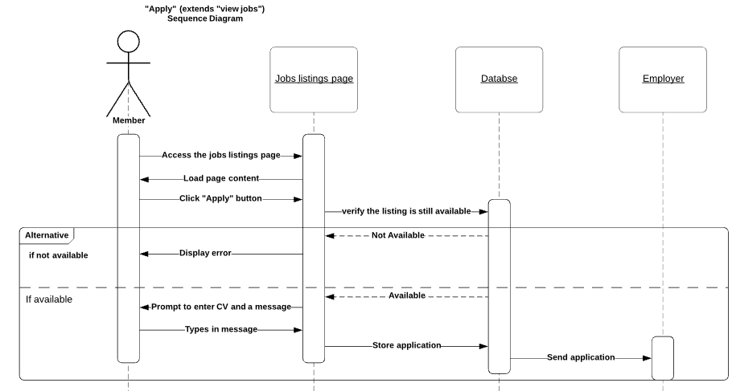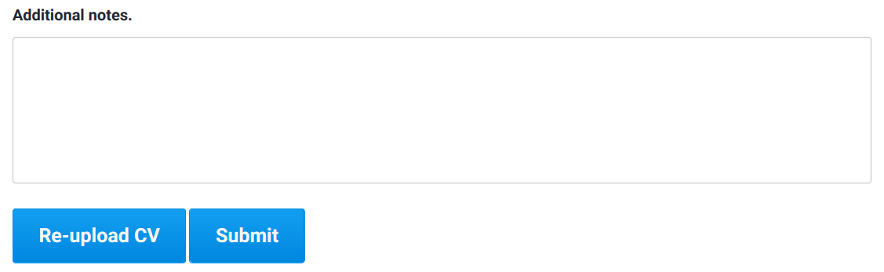

### Feedback

|  |  |  |
| --- | --- | --- |
| Use-Case Name: | Feedback | |
| Use-Case ID: | UC0240 | |
| Priority: | High | |
| Participating Actors: | Member | |
| Description: | This use case describes the event of a member wanting to give suggestions about the system, in order to help the developers. The member chooses the type of feedback he wants to give from a drop-down menu, he will then be prompted to write the subject of the feedback and a message to describe his suggestion. | |
| Precondition: | The member must be logged into the system in order to give feedback. | |
| Trigger: | This use case is triggered upon clicking the “Give Feedback” URL at the bottom of the page. | |
| Typical Course Events: | Actor Action | System Response |
| * **Step** 1: The actor writes the subject of the feedback. * **Step** 2: The actor types in the suggestion he/she wants to deliver. * **Step** 3: The actor clicks “Submit” at the end of the form. | * **Step** 3: The system checks that the subject field and the content of the feedback are not empty. * **Step** 4: The system stores the message and sends it to the admins. |
| Alternate Courses: | * Alt-Step 3: The actor left one of the fields empty; the system alerts the actor that both fields are required. | |
| Conclusion: | This use case concludes when the message is successfully sent to the admins. | |
| Postcondition: | The actor was able to give suggestion for a feature that he/she would like to be added/improved in the system. | |

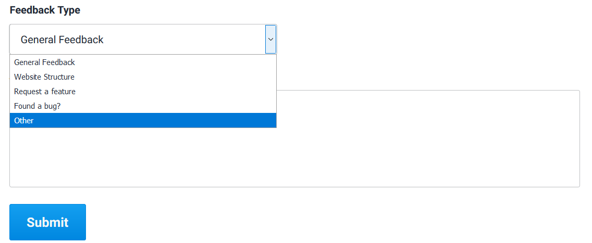

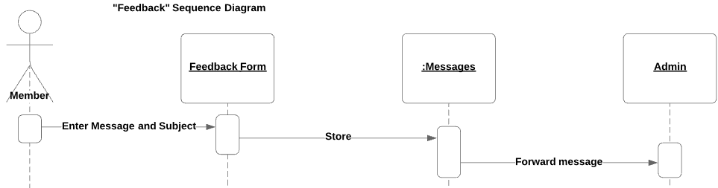

### Update Profile

|  |  |  |  |
| --- | --- | --- | --- |
| Use-Case Name: | Update Profile | | |
| Use-Case ID: | UC0250 | | |
| Priority: | High | | |
| Participating Actors: | Member | | |
| Description: | This use case describes the event when a member wants to update his/her profile in order to upload an updated CV, or change his/her account credentials, the member can also choose to upload/change a profile picture. | | |
| Precondition: | The member must be logged into the system in order update his/her profile. | | |
| Trigger: | This use case is triggered upon clicking the member’s displayed username URL on the top left of the page. | | |
| Typical Course Events: | Actor Action | | System Response |
| Action 1: | * **Step** 1: The actor uploads a new picture for his/her profile. | * **Step** 2: The system verifies that the uploaded file is of the correct format and size and changes the picture. |
| Action 2: | * **Step** 1: The actor changes the email linked to his account. | * **Step** 2: The system checks if the new email is valid. * **Step** 3: The system updates the related email in the Person database. |
| Action 3: | * **Step** 1: The actor changes the password. * **Step** 3: The actor enters his/her old and new passwords. | * **Step** 2: The system asks the actor to enter his old password, and the new password. * **Step** 4: The system checks if the old password is correct and if the new password is valid. * **Step** 5**:** The system saves the changes in the Person database. |
| Action 4: | * **Step** 1: The actor uploads a new CV. | * **Step** 2: The system checks if the new file is of the correct format. * **Step** 3:The system links the new CV to the account and deletes the old one. |
| Action 5: | * **Step** 1: The actor changes the his/her address. | * **Step** 2: The system verifies that the address exists and changes it. |
| Alternate Courses: | Action 1: | Alt-Step 2: The actor uploaded a file of the wrong format or wrong size; the system informs the actor that the format/size is no compatible and asks him/her to upload a new one. | |
| Action 2: | Alt-Step 2: The actor entered an invalid email; the system informs the actor that the email is invalid. | |
| Action 3: | Alt-Step 5: The actor entered an invalid password; the system prompts the actor to enter a different password meeting the requirements. | |
| Action 4: | Alt-Step 2: The actor uploaded a CV with an incompatible format; the system informs the actor and prompts him/her to upload a new one. | |
| Action 5: | Alt-Step 2: The actor entered an invalid address; the system informs the user that the entered address must exist. | |
| Conclusion: | Each action concludes when the actor enters the proper the information and successfully changes his/her information. | | |
| Postcondition: | The actor was able to update outdated information about him/her or change information that he/she mis-entered while registering. | | |

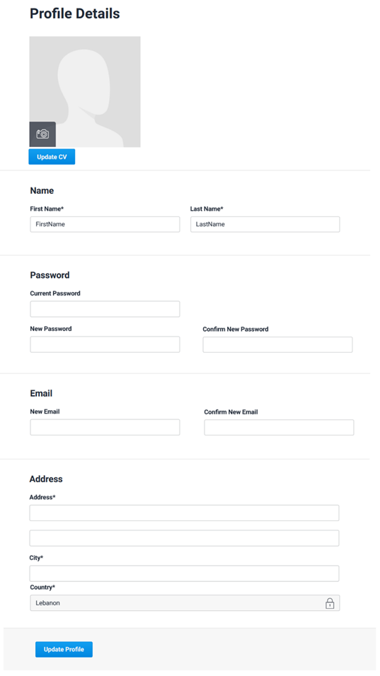

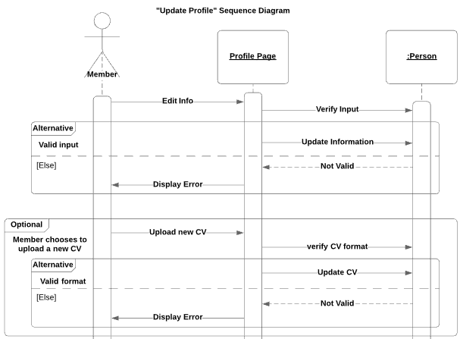

### Contact

|  |  |  |
| --- | --- | --- |
| Use-Case Name: | Contact | |
| Use-Case ID: | UC0260 | |
| Priority: | High | |
| Participating Actors: | * Member * Guest | |
| Description: | This use case describes the event of a member/guest needing to contact the admins for inquiries about the system, or to report a problem he/she is facing. The member/guest will have the ability to choose the type of topic he is contacting the admins about, he will then be given the option to head to the FAQ section that talks about that topic, if he/she chooses to proceed to contact the admins with a message, | |
| Precondition: | The actor must be on the website in order to start this use case. | |
| Trigger: | This use case is triggered upon clicking the “Contact Us” URL at the bottom of the page. | |
| Typical Course Events: | Actor Action | System Response |
| * **Step** 1: The actor clicks on “Type” drop down menu and choose the type of inquiry. * **Step** 3: The actor writes the subject title. * **Step** 4: The actor writes the content of his inquiry. * **Step** 6: The actor clicks the “Send” button at the bottom of the form. | * **Step** 2: The system gives the actor an option to go to the FAQ section before contacting the admins. * **Step** 5: The system checks that the Subject and the content fields are not empty. * **Step** 7: The message is stored and sent to the admins. |
| Alternate Courses: | * Alt-Step 2: The actor chose to go to the FAQ section, thus ending the use case. * Alt-Step 5: The actor didn’t fill the subject/content field; the system alerts the actor and asks him/her to not leave them empty. | |
| Conclusion: | This use case concludes when the message is delivered to the admins | |
| Postcondition: | The actor is able to stay in touch with the people behind the system in order to keep a better understanding of what is going on and to solve any issues that come up. | |

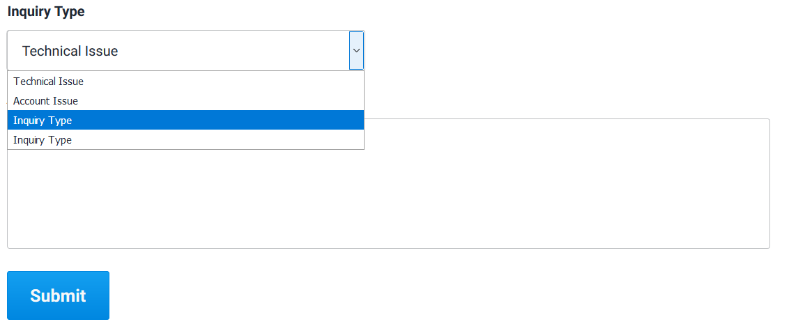

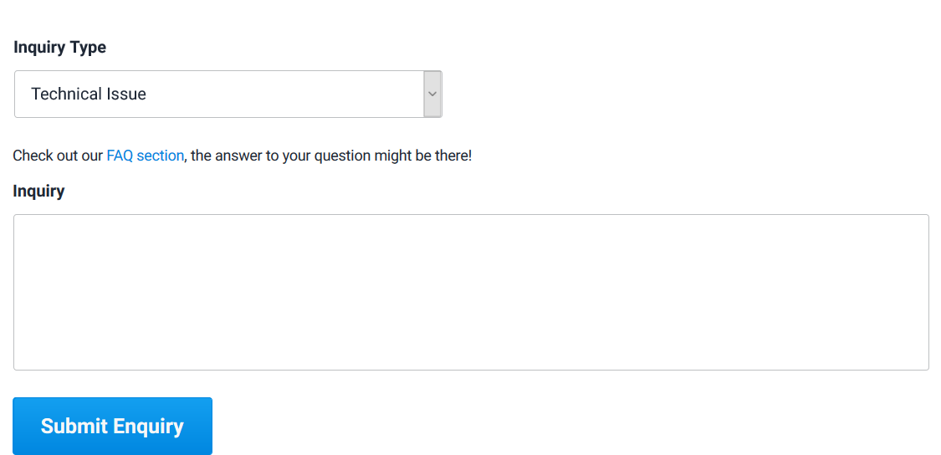

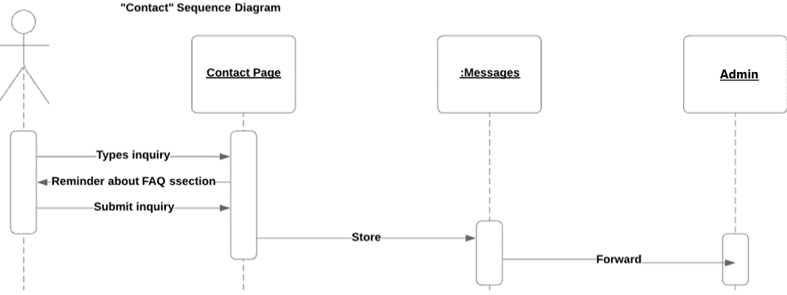

### Add companies

|  |  |  |
| --- | --- | --- |
| Use-Case Name: | Add Companies | |
| Use-Case ID: | UC0320 | |
| Priority: | High | |
| Participating Actors: | Admin | |
| Description: | This use case describes the event of an admin proceeding to add a company that chose to list its job vacancies in the system. The admin then adds the company’s information. The system ,in return, will store the company’s information. | |
| Precondition: | The admin must be logged into the system and the company must not already exist in the database. | |
| Trigger: | This use case is triggered upon clicking the “Add Company” button in the companies’ database. | |
| Typical Course Events: | Actor Action | System Response |
| * **Step** 1: The actor enters the company’s name, ID, description, contact info. | * **Step** 2: The system verifies that the ID is unique. * **Step** 3: The system adds the company to the companies’ database and links it to all the job listings that belong to it. |
| Alternate Courses: | Alt-Step 2: The ID already exists; ask the user to enter a different unique ID. | |
| Conclusion: | This use case concludes when the company is added to the database. | |
| Postcondition: | The company now exists as a verified employer in the system and can have job listings to hire employees. | |

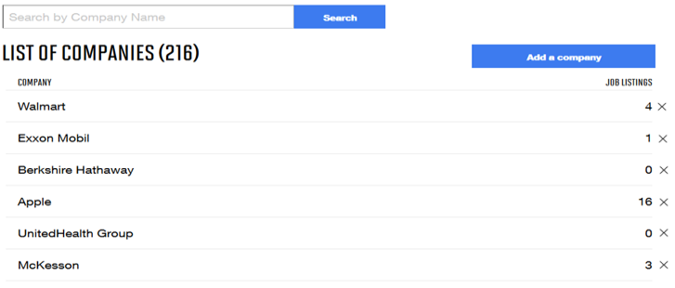

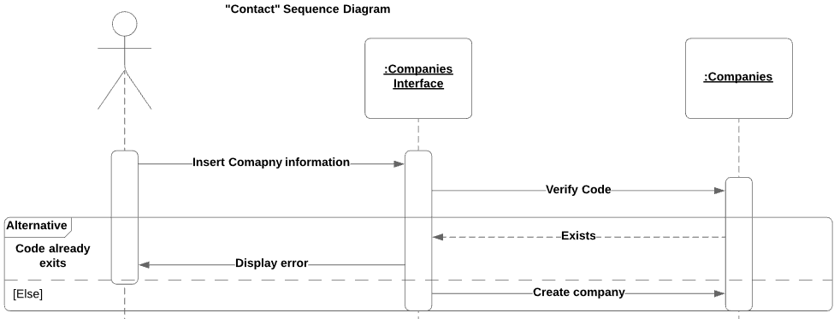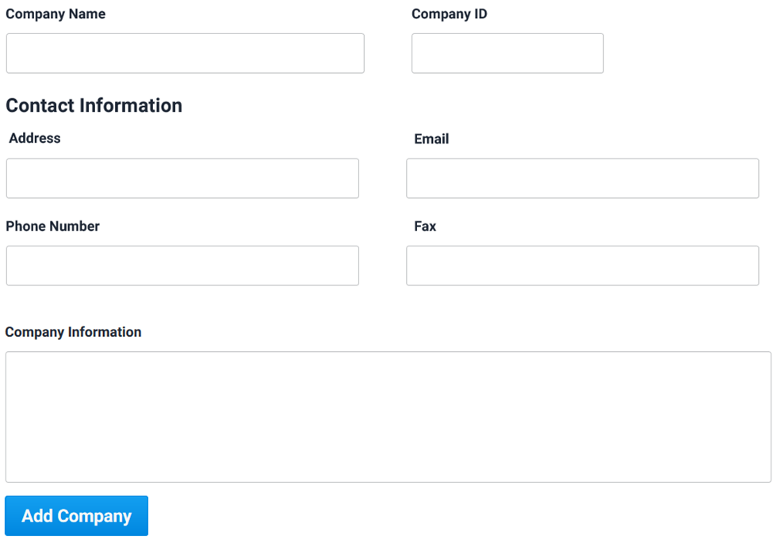

### Add jobs

|  |  |  |
| --- | --- | --- |
| Use-Case Name: | Add Jobs | |
| Use-Case ID: | UC0330 | |
| Priority: | High | |
| Participating Actors: | Admin | |
| Description: | This use case describes the event of an admin adding job offerings after the company informing him/her about the job vacancies that arise. In response, the system will add the job offering under the company’s name in the database. | |
| Precondition: | The admin must be logged into the system to add job listings. | |
| Trigger: | This use case is triggered upon clicking the “Add a Job Listing” button in the jobs’ database. | |
| Typical Course Events: | Actor Action | System Response |
| * **Step** 1: The actor enters the job’s title, ID, description, and links it with the its company. | * **Step** 2: The system verifies that the ID is unique. * **Step** 3: The system adds the job to the Jobs database and makes it available for members. |
| Alternate Courses: | * Alt-Step 2: The ID already exists; ask the user to enter a different unique ID. | |
| Conclusion: | This use case concludes when the job is added to the database. | |
| Postcondition: | The job is now up among the listings and can receive applicants. | |

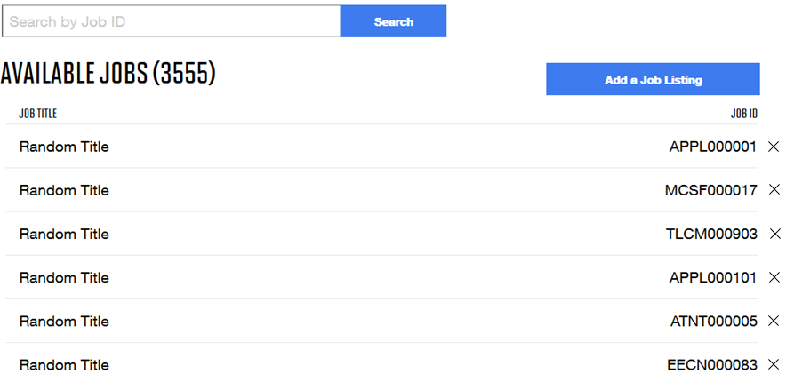

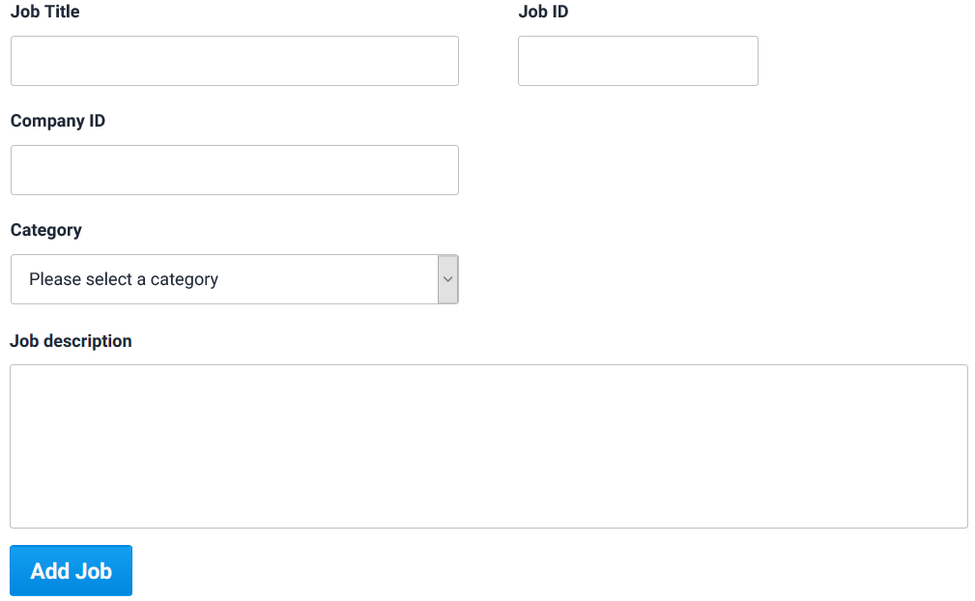

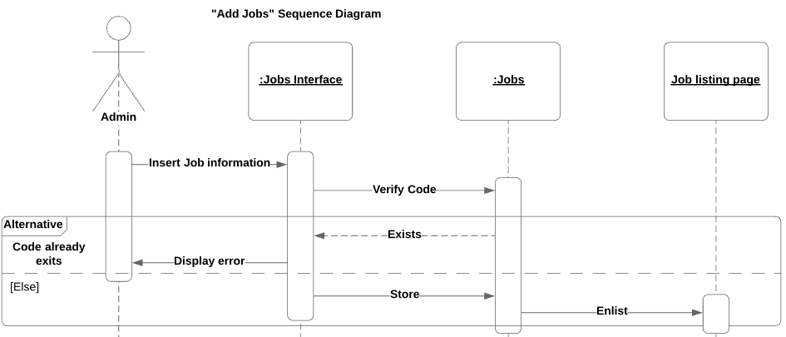

### Remove jobs

|  |  |  |
| --- | --- | --- |
| Use-Case Name: | Remove jobs | |
| Use-Case ID: | UC0340 | |
| Priority: | High | |
| Participating Actors: | Admin | |
| Description: | This use case describes the event of an admin removing job offerings after the company informing him/her about the job vacancies that have been filled. In response, the system will delete the job from the database offering making it no longer viewable by members, the system will also inform any pending applicants that the job is no longer available. | |
| Precondition: | The admin must be logged into the system to Remove job listings. | |
| Trigger: | This use case is triggered upon clicking the “x” button beside a specific job in the database. | |
| Typical Course Events: | Actor Action | System Response |
| * **Step** 2: The actor clicks “confirm button”. | * **Step** 1: The system asks the actor for confirmation. * **Step** 3: The system sends a notification to all pending applicants that the job is no longer available. |
| Alternate Courses: | Alt-Step 2: The actor doesn’t confirm the action; the action doesn’t proceed. | |
| Conclusion: | This use case concludes when the notification is sent to the pending applicants. | |
| \ | The job is removed and is no longer visible to be applied to. | |

### View members

|  |  |  |
| --- | --- | --- |
| Use-Case Name: | View members | |
| Use-Case ID: | UC0350 | |
| Priority: | High | |
| Participating Actors: | Admin | |
| Description: | This use case describes the event of an admin viewing regular members having access to their information, credentials. The admin will have the option to make changes to this member’s account and information, this might be needed for moderation and security reasons. | |
| Precondition: | The admin must be logged into the system to view members. | |
| Trigger: | This use case is triggered upon clicking the member’s name in the database. | |
| Typical Course Events: | Actor Action | System Response |
| No Actor Action beyond the trigger. | **Step** 1: The system directs the actor to the selected member’s profile. |
| Alternate Courses: | There are no alternate courses. | |
| Conclusion: | This use case concludes when the actor is directed to the member’s profile. | |
| Postcondition: | The admin is able to view certain information about members. | |

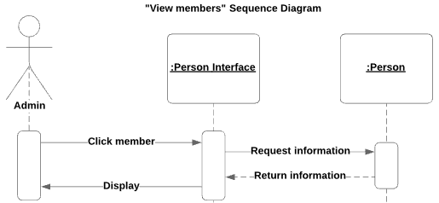

### Edit members

|  |  |  |  |
| --- | --- | --- | --- |
| Use-Case Name: | Edit members | | |
| Use-Case ID: | UC0351 | | |
| Priority: | High | | |
| Participating Actors: | Admin | | |
| Description: | This use case extends the view members use case, it allows the admin to moderate the system by banning, deleting, warning, or changing members’ accounts. The system will ban, delete, flag, or change information accordingly and inform the member. | | |
| Precondition: | The admin must be logged into the system and viewing the member. | | |
| Trigger: | This use case is triggered upon clicking the “Actions” button at the top of a member’s profile. | | |
| Typical Course Events: | Actor Action | | System Response |
| Action 1: | * **Step** 1: The actor clicks “Ban” in the actions’ menu. * **Step** 3: The actor writes a message and chooses the duration of the ban. * **Step** 4: The actor confirms. | * **Step** 2: The system pops a window to write a message to be sent to the member and to the duration of the ban. * **Step** 5: The system bans the member for the set duration and delivers the message. |
| Action 2 : | * **Step** 1: The actor clicks “Delete” in the actions’ menu. * **Step** 3: The actor confirms the process. | * **Step** 2: The system alerts the admin asking to confirm the process. * **Step** 4: The member’s account is no longer accessible or visible permanently. |
| Action 3: | * **Step** 1: The actor clicks “ Warn” in the actions’ menu. * **Step** 3: The actor writes the message. * **Step** 4: The actor confirms. | * **Step** 2: The system pops a window requiring a message to be sent to the member as a warning. * **Step** 5: The member receives the message and his/her account is now flagged. |
| Action 4: | * **Step** 1: The actor edits whatever he/she deems necessary in the member’s profile * **Step** 2: The actor writes and confirms. | * **Step** 3: The system asks the actor to write a reason behind the change. * **Step** 4: The system sends a message to the member informing him/her of the changes and the reasoning behind them. |
| Alternate Courses: | Action 1: | * Alt-Step 4: The actor doesn’t click “Confirm”; the following **Step**s are terminated. | |
| Action 3: | * Alt-Step 4: The actor doesn’t click “Confirm”; the following **Step**s are terminated. | |
| Conclusion: | This use case is concluded when the related action is completed by the system. | | |
| Postcondition: | The admins are able to moderate the website by banning/delete/flagging/editing the accounts of members breaking the rules while keeping the members informed when needed. | | |

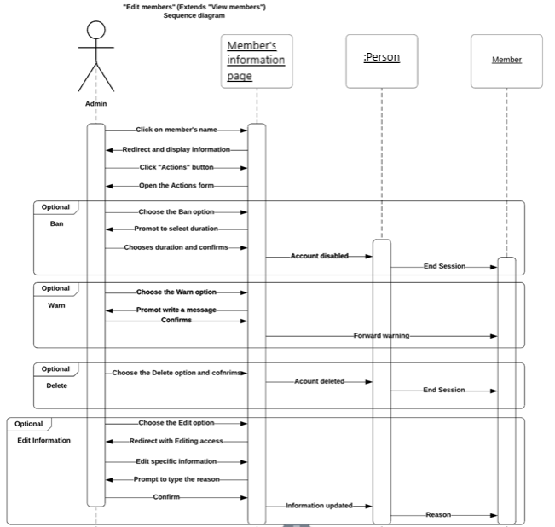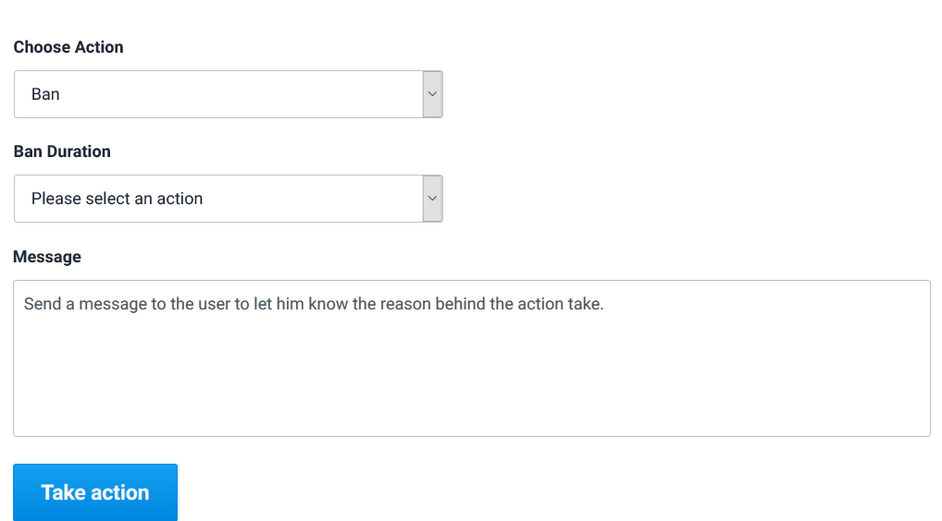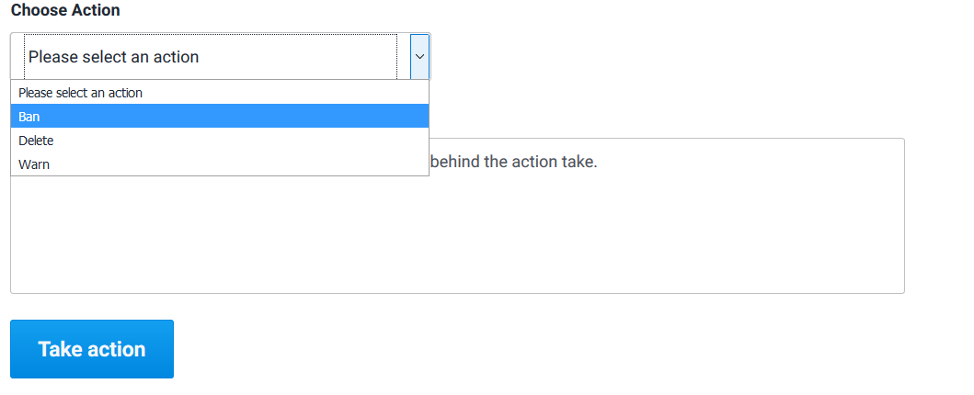

### Reply

|  |  |  |
| --- | --- | --- |
| Use-Case Name: | Reply | |
| Use-Case ID: | UC0360 | |
| Priority: | High | |
| Participating Actors: | Admin | |
| Description: | This use case describes the event of an admin viewing the feedback and inquiries that the members sent and reply to them answering their question, informing them that their problem is fixed, or thanking them for their feedback. This use case helps in showing the members that the developers and admins are closely looking after the system and always seeking improvements. | |
| Precondition: | The admin must receive a “contact” message. | |
| Trigger: | This use case is triggered by clicking on the “Reply” button below the currently open message. | |
| Typical Course Events: | Actor Action | System Response |
| * **Step** 2: The actor writes the response for the inquiry. * **Step** 3: The actor confirms. | * **Step** 1: The system expands a text box for the message to be written in. * **Step** 4: The system stores and delivers the response to the original sender. |
| Alternate Courses: | * Alt-Step 4: The actor left the text box empty; the system alerts the actor and asks him/her to not leave it empty. | |
| Conclusion: | This use case is concluded when the response is delivered to the original sender. | |
| Postcondition: | The admin is able to reply to inquiries, answer question, and solve problems for members so that they can keep the members in touch. | |

# Data Modeling

## Context Data Model

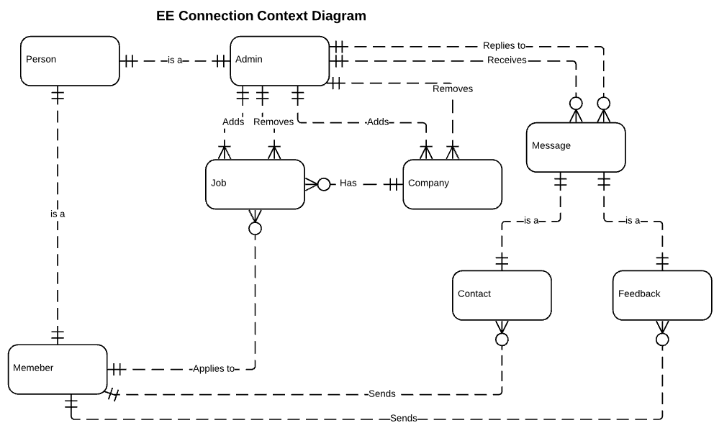

Made with Lucidchart

## Conceptual Data Model

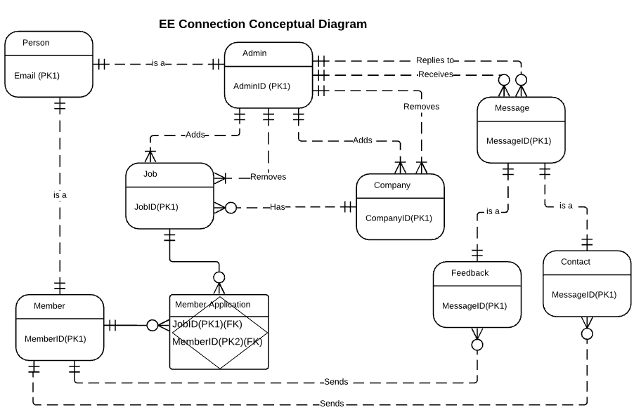

Made with Lucidchart

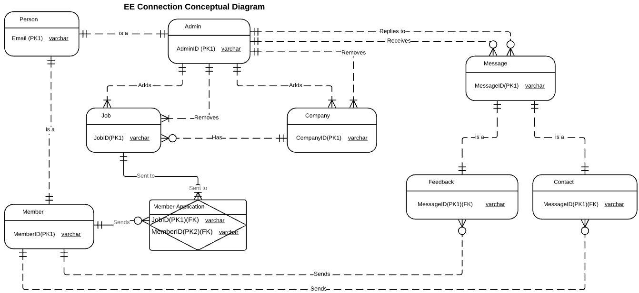

Made with Lucidchart

## Physical Data Model

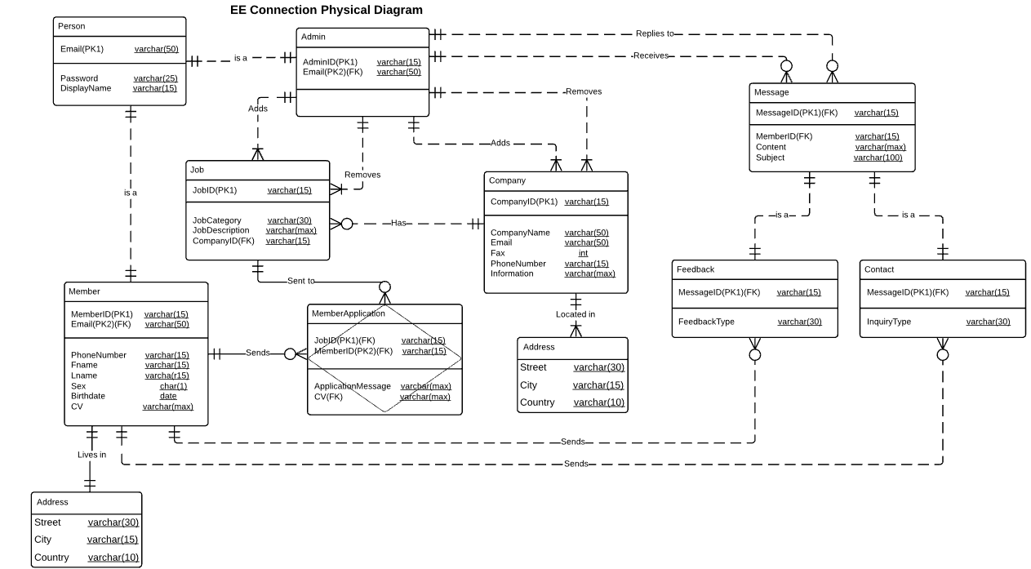

Made with Lucidchart